ROBOT ORIENTING TOWARDS AND MOVING TOWARDS THE TARGET/ENEMY
Alp Onurkan DURAN¹, Barış MUTLU², Elifcan ZABUN³, Muhammed KILIÇ⁴, Yağmur UĞUR⁵

^{1,2,3,4,5}Department of Electrical and Electronics Engineering, Zonguldak Bülent Ecevit University, Zonguldak, Türkiye
a.duran@ mf.karaelmas.edu.tr 210106106050
baris.m@mf.karaelmas.edu.tr 210106106063
e.zabun@mf.karaelmas.edu.tr 210106106061
muhammed.kilic@mf.karaelmas.edu.tr 210106106025
yagmur.ugur@mf.karaelmas.edu.tr 210106106055

Abstract— This report presents the nonlinear control architecture, theoretical foundations, and simulation results of an autonomous mobile robot tasked with orienting towards and moving towards a target. The main focus of the study is to develop an effective control strategy capable of managing robots’ inherently nonlinear kinematics and dynamics. The robot model is based on a 5-dimensional dynamic state space ($z={\left[x,y,θ,v,ω\right]}^{T}$) that includes physical effects such as mass ($m$), moment of inertia ($I$), and friction ($μ$). The simulation environment also features moving 3D obstacles and a dynamically modeled target that avoids obstacles. To control this nonlinear system, a cascaded control architecture has been designed. The outer loop (High-Level Controller) generates the “desired” velocities ($v_{desired},ω_{desired}$) using a nonlinear control law based on Artificial Potential Fields (APF), which combines the robot’s geometric error ($ρ$: distance, $α$: angle) relative to the target and the repulsive potential field effects from surrounding obstacles. The inner loop (Low-Level Controller) is a linear P-type velocity controller that calculates the necessary Force ($F$) and Torque ($τ$) inputs to close the gap between these desired velocities and the system’s “actual” velocities. The report analyzes the design of this controller structure, the geometric derivation of error variables, the integration of the APF method for reactive obstacle avoidance, the selection principles for control gains ($k_{v},k_{w},k_{F},k_{Tau},k_{rep}$), and their effects on system stability and tracking performance. MATLAB simulation results, involving the tracking of a dynamic and avoiding target amidst moving obstacles, confirm that the designed nonlinear control strategy successfully manages the system’s inertia, friction, and environmental challenges, tracking the target with stability and acceptable error.
Keywords Reactive — Nonlinear Control, Cascaded Control, Artificial Potential Fields (APF), 5-Dimensional State Space, Target Tracking.

Giriş
Target tracking in mobile robotics presents complex engineering problems due to dynamic environmental conditions, sensor uncertainties, and real-time decision-making requirements [1]. This study addresses the tasks of target orientation and controlled pursuit/approach within the specific context of an “attack robot” scenario, tracking a dynamic, obstacle-avoiding target in 3D space amidst moving obstacles. From the perspective of Nonlinear Control Systems, the core of
this problem lies in the nonlinear nature of the system and the task.
The “unicycle” model, which describes the robot’s basic motion, is inherently nonlinear due to the trigonometric functions ($\dot{x}=vcos\left(θ\right)$, $\dot{y}=vsin\left(θ\right)$) involving the state variable $θ$ in its kinematic equations [2]. Furthermore, the error definitions naturally arising for the target reaching task (distance $ρ=\sqrt{…}$, angle $α=\text{atan2}\left(…\right)-θ$) also involve nonlinear functions. Additionally, the Artificial Potential Field (APF) method used in this project for obstacle avoidance defines nonlinear repulsive forces inversely proportional to the distance to obstacles [3]. These factors preclude the direct and effective application of standard linear control theory tools (e.g., applying PID control directly to position errors, pole placement in state space). Approaches like linearization might be valid around specific operating points but can be inadequate in situations like this, where the robot moves over a wide area with large orientation changes. Therefore, the use of control techniques that directly address the system’s nonlinear structure is necessary [4].
Another control challenge in this study stems from moving beyond the simple kinematic model to utilize a 5-dimensional state space model that incorporates the robot’s dynamics (mass $m$, inertia $I$, friction $μ$) [5. In this case, the control inputs are no longer the ideal velocities ($v,ω$) but the physical Force ($F$) and Torque ($τ$) that generate these velocities This makes the control problem higher order and involves indirect inputs: The controller must not only ensure geometric target tracking and obstacle avoidance but also generate appropriate force/torque values to overcome the robot’s physical inertia and achieve the desired velocities.
To manage this nonlinear and dynamic system, this work adopts a two-layer, cascaded control strategy. The outer layer (High-Level Controller) generates “desired” velocities based on geometric errors and the APF potential field using a nonlinear law; the inner layer (Low-Level Controller) uses a linear velocity controller to track these velocity commands by calculating the required $F$ and $τ$. This architecture decomposes the complex problem into two more manageable sub-problems, allowing each layer to focus on its specific task. This report analyzes the designed cascaded control architecture, the employed nonlinear APF-based control law, the influence of gains on system performance (stability, tracking accuracy, response speed), and the obtained simulation results within the framework of Nonlinear Control Systems principles.

System Model and Control Problem Defınıtıon
Effective control system design begins with a clear and accurate mathematical representation of the system to be controlled, often referred to as the 'plant'. This model serves as the foundation upon which control strategies are developed and analyzed. For complex systems, particularly those exhibiting nonlinear behavior and significant dynamic effects like the mobile robot considered in this study, establishing an appropriate model is crucial. A model that is too simple may fail to capture essential behaviors, leading to poor controller performance in practice, while an overly complex model can render controller design and analysis intractable. Therefore, this section first details the 5-dimensional dynamic state-space model chosen to represent the "attack robot," explicitly incorporating its kinematic nonlinearities and dominant dynamic characteristics such as mass, inertia, and friction. Subsequently, the specific control objectives for this system are precisely defined. Clearly articulating the desired performance goals—such as tracking a time-varying reference trajectory, rejecting disturbances (implicitly, via obstacle avoidance), maintaining stability, and respecting physical constraints—is essential for designing an appropriate controller and evaluating its success. This systematic definition of both the system model and the control objectives form the necessary groundwork for the subsequent design of the cascaded, APF-based nonlinear controller in Section 3.

System to be Controlled: 5-Dimensional Dynamic Model
The system under control is the 5-dimensional dynamic state-space model detailed previously:
$z={\left[x,y,θ,v,ω\right]}^{T}$ (1)
The system dynamics are defined by the following differential equations:
$\dot{x}=vcos\left(θ\right) \text{(Nonlinear Kinematics)}$ (2)
$$\dot{y}=vsin\left(θ\right) \text{(Nonlinear Kinematics) (3)}$$
$\dot{θ}=ω \text{(Kinematics)}$(4)
$$\dot{v}=\left(F-μ_{v}⋅v\right)/m \text{(Dynamics with nonlinear friction)} \text{(5)}$$
$$\dot{ω}=\left(τ-μ_{w}⋅ω\right)/I \text{(Dynamics with nonlinear friction) (6)}$$
Here, the control inputs are $u={\left[F,τ\right]}^{T}$ and the state vector is $z$. The system exhibits nonlinearities in both its kinematics ($cosθ,sinθ$) and dynamics (velocity-dependent friction terms $μ_{v}v,μ_{w}ω$) [6].

Control Objective
The objective for this study is to regulate the first three elements of the robot’s state vector ($x,y,θ$) according to a time-varying target reference ($hedef_pos\left(t\right)$) while simultaneously avoiding moving obstacles (obstacle_current_centers). Specifically, the robot must:
- Position Tracking and Orientation: Keep its position $\left(x,y\right)$ as close as possible to the target’s 2D (X-Y) projection $\left(x_{g}\left(t\right),y_{g}\left(t\right)\right)$, and continuously adjust its orientation ($θ$) towards the target ($\text{atan2}\left(y_{g}-y,x_{g}-x\right)$). That is, minimize the distance error $ρ\left(t\right)=\sqrt{{\left(x_{g}\left(t\right)-x\left(t\right)\right)}^{2}+{\left(y_{g}\left(t\right)-y\left(t\right)\right)}^{2}}$ and the angle error $α\left(t\right)=\text{atan2}\left(y_{g}\left(t\right)-y\left(t\right),x_{g}\left(t\right)-x\left(t\right)\right)-θ\left(t\right)$.
- Obstacle Avoidance: Avoid collisions with the defined moving obstacles (obstacles) during motion.
These objectives must be achieved under the system’s dynamic constraints ($m,I,μ$) using only the $F$ and $τ$ inputs. This constitutes a typical nonlinear tracking and regulation (obstacle avoidance) problem [7].

Cascaded APF-Based Nonlinear Controller Design
To solve this nonlinear and dynamic control problem, a cascaded control architecture is designed. This approach involves partitioning the overall control task into hierarchical levels or loops, effectively breaking down the complex 5-dimensional system into two simpler, interconnected subsystems. Think of it like managing a large project: you have a high-level manager setting the overall goals and deadlines (the outer loop), and specialized engineers handling the detailed technical tasks to meet those goals (the inner loop).
This architecture is particularly effective for systems, like our mobile robot, where there's a natural separation in time scales between different parts of the dynamics. Specifically:
- Outer Loop Dynamics: This loop deals with the robot's position and orientation relative to the target and obstacles. Changes in position happen relatively slowly as they are the result of integrated velocities over time. This loop handles the geometric aspects of the task, including the nonlinear calculations for distance, angle and the APF logic. Its goal is to determine the desired velocities needed to progress towards the target safely.
- Inner Loop Dynamics: This loop deals with the robot's actual velocities and how they respond to the applied Forces and Torques. Velocity changes occur much faster than position changes, dictated by the robot's mass inertia and the applied forces/torques. Its goal is to make the actual velocities track the desired velocities commanded by the outer loop as quickly and accurately as possible.
The key advantage of this cascaded structure lies in this time-scale separation. Because the inner loop (velocity control) is designed to be much faster and more responsive than the outer loop (position/guidance control), the outer loop controller can be designed as if its velocity commands are achieved almost instantaneously. This significantly simplifies the design of the outer loop, allowing it to focus solely on the complex, nonlinear geometry and APF logic without needing to explicitly worry about the intricate details of motor dynamics, inertia, and friction. The inner loop takes care of handling those physical aspects, ensuring the robot's actuators deliver the performance requested by the high-level guidance commands. This modularity also makes tuning easier, as the inner velocity loop can often be tuned independently first, followed by the tuning of the outer position loop [8].
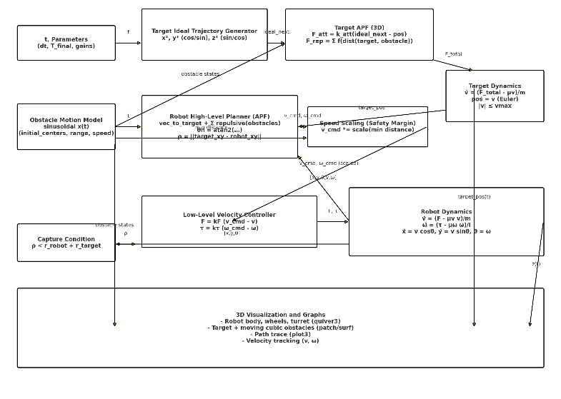
Figure 1 Cascaded Control Architecture of the 5D Dynamic System.

Outer Loop: APF-Based Nonlinear Controller (High Level)
The task of the outer loop is to compute the ideal or “desired” velocities ($v_{desired},ω_{desired}$) required for the robot to safely navigate towards the target, based on the current target position and obstacle locations. This layer relies on the Artificial Potential Field (APF) method.
APF Logic: The environment is modeled as a potential field with an attractive force (${\vec{F}}_{att}$) towards the target and repulsive forces (${\vec{F}}_{rep}$) pushing away from obstacles. The desired direction of motion is determined by the resultant force vector (${\vec{F}}_{total}={\vec{F}}_{att}+{\vec{F}}_{rep}$).
Calculation Steps:
- Attractive Vector (${\vec{F}}_{att}$-like): A unit vector (attractive_vector_xy) pointing from the robot’s current X-Y position towards the target’s X-Y position is calculated. This indicates the direction of attraction.
- Repulsive Vectors (${\vec{F}}_{rep}$): For each moving obstacle within the detection radius (detection_radius_robot):
- The X-Y distance (dist_to_obs) to the obstacle is computed.
- A nonlinear APF formula calculates the magnitude of the repulsive force (repulsion_strength_robot), which increases inversely with the square of the distance (scaled by gain $k_{rep_robot}$).
- A repulsive force vector (repulsive_vector) pointing away from the obstacle is determined.
- All repulsive vectors from nearby obstacles are summed (total_repulsive_vector_robot_xy).
- Net Direction Vector: ${\vec{V}}_{net}={\vec{V}}_{att}+{\vec{V}}_{rep}$ (final_direction_vector_xy). This vector combines the desire to reach the target with the need to avoid obstacles.
- Angle Error ($α$): The difference between the angle of this net direction vector (target_angle_combined) and the robot’s current orientation ($θ$) is calculated. This involves atan2 and is nonlinear.
- Distance Error ($ρ$): The X-Y distance to the target (involves sqrt, nonlinear).
Nonlinear Control Law: The desired velocities are determined using the calculated $ρ$ and the (APF-modified) $α$:
$$v_{desired}=k_{v}⋅ρ \text{(7)}$$
$$ω_{desired}=k_{w}⋅α \text{(8)}$$
Additionally, the v_desired value is dynamically reduced based on the minimum distance to an obstacle (min_dist_to_obstacle_robot), which is also a nonlinear modification.
- Gains ($k_{v},k_{w},k_{rep_robot}$): These gains tune the balance between attraction to the target, turning speed, and repulsion from obstacles. Improper selection can lead to the robot failing to reach the target (e.g., if repulsion is too strong) or colliding with obstacles (e.g., if repulsion is too weak). Turning these gains for stability and performance is crucial. In this work, $k_{v}=0.9$, $k_{w}=1.8$, and $k_{rep_robot}=250.0$ were chosen.
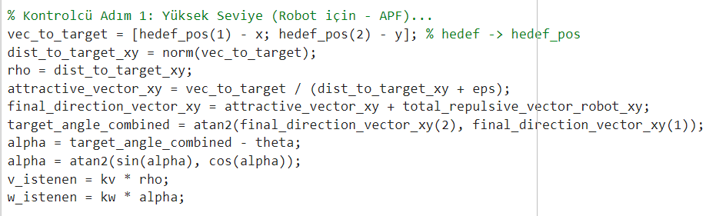
Figure 2. APF-Based High-Level Controller Code for the Robot.

Inner Loop: Linear Dynamic Controller (Low Level - Velocity Tracking)
The task of the inner loop is to take the ideal velocity commands ($v_{desired},ω_{desired}$) from the outer loop and make the robot’s actual physical velocities ($v_{actual},ω_{actual}$) match these commands quickly and accurately. This loop directly manages the robot’s dynamics ($m,I,μ$).
Velocity Error Variables: The inner loop uses simple velocity differences as errors:
$${ e}_{v}=v_{desired}-v_{actual} \text{(9)}$$
$$e_{ω}=ω_{desired}-ω_{actual} \text{(10)}$$
Linear Control Law: A simple P-type (Proportional) linear controller is used to close these velocity error loops. The controller outputs are the physical Force ($F$) and Torque ($τ$) applied to the system (Physics Engine block):
$$F=k_{F}⋅e_{v} \text{(11)}$$
$$τ=k_{Tau}⋅e_{ω} \text{(12)}$$
- Gains ($k_{F},k_{Tau}$): These gains determine the bandwidth of the inner loop. They are chosen sufficiently high to ensure the inner loop operates much faster than the outer loop (time-scale separation). This allows the outer loop designer to assume that the inner loop tracks its commands nearly perfectly. However, excessively high gains can amplify noise or lead to instability. In this work, high values were chosen: $k_{F}=50.0$ and $k_{Tau}=20.0$.
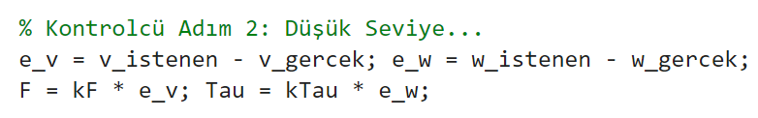
Figure 3. Linear P-Type Velocity Controller Code (Inner Loop).

Simulation Results and Control Performance Analysis
The performance of the designed cascaded, APF-based nonlinear controller was rigorously tested through dynamic simulation in MATLAB, employing the challenging scenario involving a 3D moving target and dynamic, moving obstacles. This complex environment serves as a demanding testbed, crucial for evaluating the controller's effectiveness beyond simple point-to-point navigation or static obstacle avoidance tasks. This section analyzes the quantitative (e.g., error plots, velocity tracking) and qualitative (e.g., 3D trajectory visualization) results obtained from these simulations, interpreting them specifically from a control theory perspective. The focus will be placed on assessing key performance metrics fundamental to control system evaluation, such as overall stability, tracking accuracy (considering both steady-state and transient errors), system response speed to target and obstacle movements, the observable influence of system nonlinearities (including APF effects), and the effectiveness of the cascaded architecture in synergistically managing both the high-level kinematic task and the underlying physical dynamics.
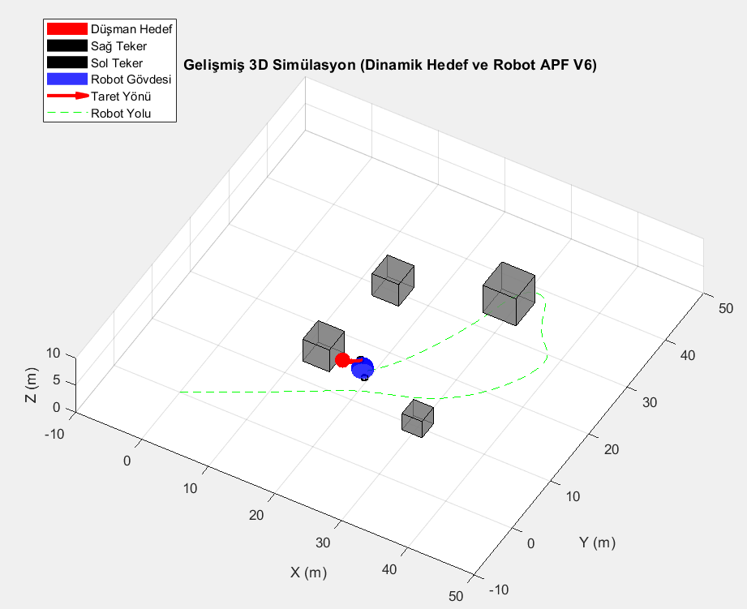
Figure 4. 3D trajectory tracking and obstacle avoidance by the robot
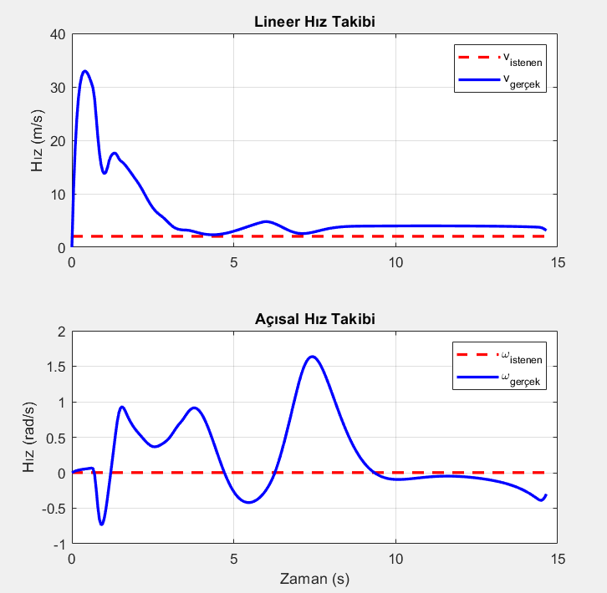
Figure 5. Velocity tracking performance of the low-level controller

Low-Level Controller Performance (Velocity Tracking - Figure 5)
One of the most critical analyses for Nonlinear Control is how well the inner loop (velocity controller) tracks the commands from the outer loop (position controller). The graphs in Figure 5 illustrate this performance.
- Observations:
  - Good Tracking: The blue lines (actual velocities) generally follow the red dashed lines (desired velocities) well. This indicates that the inner loop gains ($k_{F},k_{Tau}$) are sufficiently high and the low-level controller fulfills its task.
  - Dynamic Effects (Lag and Overshoot): Actual velocities lag behind and occasionally overshoot desired commands, particularly during transients like the start-up or avoidance maneuvers5. This is the natural dynamic response stemming from the robot's mass and inertia, not a controller flaw, and is actively managed by the inner loop controller7.
  - Stability: After the initial transient behavior, the velocities remain stable around the desired values. This shows that the chosen $k_{F},k_{Tau}$ gains do not destabilize the inner loop.
- Interpretation: The performance of the inner loop validates the time-scale separation assumption often made in cascaded control design. The outer loop can reasonably assume that its command of velocity will be followed relatively quickly by the inner loop. If the tracking were poor (large lag or oscillations), the outer loop’s performance would also degrade significantly.

High-Level Controller Performance (Target Tracking and Obstacle Avoidance - Figure 4)
Given that the inner loop successfully executes velocity commands, we can evaluate how well the outer loop (nonlinear APF + geometric control) achieves its primary goal.
- Observations (Figure 4):
  - Successful Obstacle Avoidance: The robot’s trajectory (green dashed line) clearly deviates from the direct path to the target to navigate around the moving gray obstacles without collision. This confirms that the APF algorithm and the repulsive gain $k_{rep_robot}$ are effective.
  - Target Tracking: After avoidance maneuvers, the robot redirects itself towards the dynamically moving and avoiding target (red sphere) and continues tracking it.
  - Stability: The overall system exhibits stable behavior, with no uncontrolled oscillations or divergence from the target. This indicates that the outer loop gains ($k_{v},k_{w}$) and APF parameters maintain stability despite the nonlinearities and dynamic environment.
  - Tracking Error: As expected, when tracking a moving target with this type of controller, a small steady-state tracking error exists between the robot’s path and the target’s path projection. Figure 4 shows this error is small and acceptable. The magnitude of this error depends on the gains $k_{v},k_{w}$, the target’s speed, and the influence of repulsive forces.
Interpretation: The APF-based nonlinear control law in the outer loop successfully integrates the conflicting objectives of target attraction (${\vec{F}}_{att}$) and obstacle repulsion (${\vec{F}}_{rep}$). The outer loop effectively commands the robot’s dynamics via the inner loop to achieve this complex task. While APF is known to potentially suffer from local minima issues, successful tracking was observed in this scenario

Notes on Stability
The simulation results experimentally demonstrate that the system is stable with the chosen parameters (errors remain bounded, system does not crash). Formal stability analysis of such nonlinear, cascaded systems involving APF is complex and typically requires Lyapunov theory. For instance, one might attempt to prove stability by showing that the time derivative of a Lyapunov candidate function like $V=\frac{1}{2}ρ^{2}+λ\frac{1}{2}α^{2}$ (where $λ>0$), possibly augmented with terms related to obstacle potentials, is negative semi-definite. However, such analysis is beyond the scope of this report. The simulations provide practical evidence of stable behavior under the tested conditions.

Conclusıon and Future Work
This study successfully presented the design and MATLAB simulation validation of a cascaded, APF-based nonlinear controller for a 5-dimensional dynamic model of an “attack robot” operating in an environment with a dynamic target and moving obstacles. The project addressed a significantly more realistic control problem than simple kinematic modeling by incorporating robot dynamics. The designed cascaded control architecture effectively decoupled the complex task into two manageable layers:
- Nonlinear Outer Loop: Utilized the APF method combined with geometric error definitions ($ρ$: distance, $α$: angle) to generate “desired” velocity commands ($v_{desired},ω_{desired}$) ensuring both target tracking and obstacle avoidance.
- Linear Inner Loop: Transformed these “desired” velocities into physical Force ($F$) and Torque ($τ$) values, accounting for the robot’s dynamics ($m,I$).
Simulation results, particularly the Velocity Tracking graphs (Figure 5), confirmed that the inner loop successfully managed the robot dynamics (with expected lag and overshoot). The 3D trajectory graph (Figure 4) demonstrated that the outer loop achieved its goals of both tracking the dynamic, avoiding target and navigating safely around moving obstacles in a stable manner. This controller structure offers a solution that is not a standard PID and explicitly handles the nonlinearities of the system and task. The obtained controller design and simulation platform provide a foundation for future control-oriented developments.
Potential future work and improvements that can be built upon this foundation include:
- Advanced Nonlinear Control Techniques: Instead of the current P-type outer loop, more systematic nonlinear methods like Backstepping or Sliding Mode Control (SMC), which can offer stronger theoretical stability guarantees, could be designed and implemented. These might provide better robustness against model uncertainties and external disturbances.
- Model Predictive Control (NMPC): Especially if the target/obstacle motion can be predicted to some extent, NMPC (Nonlinear Model Predictive Control) could significantly optimize tracking performance and control effort by considering system constraints (e.g., max $F,τ$) and future errors explicitly.
- Adaptive Control / Learning: If the robot’s parameters ($m,I,μ$) or the environment dynamics are uncertain or time-varying, adaptive control schemes (by estimating parameters) or Reinforcement Learning (RL) based controllers (learning directly from simulation interaction) could be developed to cope with these uncertainties.
- State Estimation and Noise Filtering: To handle noisy sensor measurements expected in real-world scenarios, state estimators like the Extended Kalman Filter (EKF) or Unscented Kalman Filter (UKF) should be designed and integrated. The controller would then use these filtered state estimates instead of raw measurements, improving robustness to noise.
These suggested control-focused improvements hold significant potential to further enhance the performance (e.g., faster tracking, lower error), robustness (e.g., handling uncertainties, rejecting disturbances), and overall autonomy of the designed system in more challenging scenarios.

Kaynaklar
- Siegwart, R., Nourbakhsh, I. R., & Scaramuzza, D. (2011). *Introduction to Autonomous Mobile Robots* (2nd ed.). MIT Press.
- Siciliano, B., Sciavicco, L., Villani, L., & Oriolo, G. (2009). *Robotics: Modelling, Planning and Control*. Springer.
- Borenstein, J., & Koren, Y. (1991). The vector field histogram-fast obstacle avoidance for mobile robots. *IEEE Transactions on Robotics and Automation*, *7*(3), 278–288.
- Khalil, H. K. (2014). *Nonlinear Systems* (3rd ed.). Prentice Hall.
- Craig, J. J. (2017). *Introduction to Robotics: Mechanics and Control* (4th ed.). Pearson.
- Slotine, J. J. E., & Li, W. (1991). *Applied Nonlinear Control*. Prentice Hall.
- LaValle, S. M. (2006). *Planning Algorithms*. Cambridge University Press.
- Astrom, K. J., & Murray, R. M. (2010). *Feedback Systems: An Introduction for Scientists and Engineers*. Princeton University Press.
- MathWorks. (2025). MATLAB Documentation R2025a. The MathWorks, Inc. https://www.mathworks.com/help/matlab/

